.

OCP-TAP

Large Oscillator Form-Factor

(LOF)

Version 0.1

**Hardware Specification**

Author: OCP-TAP Group

Table of Contents

1. Overview 3

1.1. Acronyms 4

2. Scope 4

3. License 5

3.1. Open Web Foundation (OWF) CLA 5

3.2. Acknowledgements 5

4. Compliance with OCP Tenets 7

4.1. Openness 7

4.2. Efficiency 7

4.3. Impact 7

4.4. Scale 7

5. Physical Specifications 8

5.1. Labeling 8

5.2. I/O 8

5.3. Foot Print and Layout 8

5.3.1. Bottom View 9

5.3.2. Side View 9

6. Hardware Management 9

7. Version Table 9

8. References 10

Appendix A - Checklist for IC approval of this Specification (to be completed by contributor(s) of this Spec) 11

Appendix B-__ <supplier name> - OCP Supplier Information and Hardware Product Recognition Checklist 12

Appendix C - Contribution Process FAQs 14

# 

# Overview

**The Large Oscillator Form-Factor (LOF)** module is a source of stable output frequency to the Time Card.

This stable frequency also provides Time Cards a holdover reference when GNSS is denied.

The OCP-TAP LOF standardizes the dimensions, layout and connectivity of modular LOF for OCP-TAP Time Cards.

A standard modular LOF allows Time Card customers to interchange and upgrade Oscillators with ease, and lets manufacturers an easier path to release new and improved holdover and stability mechanism compatible with OCP-TAP Time Cards.

The LOF can lead to a faster pace of innovation and development as manufacturers can focus on creating new components rather than iterating on the Time Servers, Time Cards and NICs for each new product or revision.

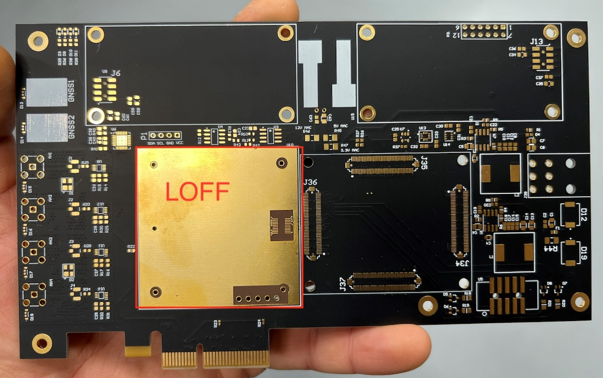

Figure - Time-Card with LOF

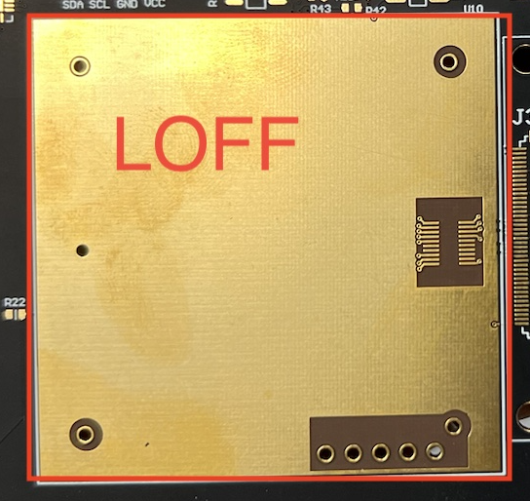

Figure – Zoom-In View of LOF

## Acronyms

|  |  |
| --- | --- |
| **Abbreviation** | **Definition** |
| LOF | Large Oscillator Form-Factor |
| NIC | Network Interface Card |
| PPS | Pulse Per Second |
| PTP | Precision Time Protocol |
| RCB | Receiver Carrier Board |
| TAP | Time Appliance Project |

# Scope

This document defines the technical details for base specification for Large Oscillator Form-Factor (LOF).

Any supplier seeking OCP recognition for a hardware product based on this Specification must be 100% compliant with all features or requirements described

# License

## Open Web Foundation (OWF) CLA

Contributions to this Specification are made under the terms and conditions set forth in Open Web Foundation Modified Contributor License Agreement (“OWF CLA 1.0”) (“Contribution License”) by:

**Meta, NVIDIA**

Usage of this Specification is governed by the terms and conditions set forth in **Open Web Foundation Modified Final Specification Agreement (“OWFa 1.0”) (“Specification License”).**

You can review the applicable OWFa1.0 Specification License(s) referenced above by the contributors to this Specification on the OCP website at <http://www.opencompute.org/participate/legal-documents/>. ​​For actual executed copies of either agreement, please contact OCP directly.

**Notes**:

1. The above license does not apply to the Appendix or Appendices. The information in the Appendix or Appendices is for reference only and non-normative in nature.

NOTWITHSTANDING THE FOREGOING LICENSES, THIS SPECIFICATION IS PROVIDED BY OCP "AS IS" AND OCP EXPRESSLY DISCLAIMS ANY WARRANTIES (EXPRESS, IMPLIED, OR OTHERWISE), INCLUDING IMPLIED WARRANTIES OF MERCHANTABILITY, NON-INFRINGEMENT, FITNESS FOR A PARTICULAR PURPOSE, OR TITLE, RELATED TO THE SPECIFICATION. NOTICE IS HEREBY GIVEN, THAT OTHER RIGHTS NOT GRANTED AS SET FORTH ABOVE, INCLUDING WITHOUT LIMITATION, RIGHTS OF THIRD PARTIES WHO DID NOT EXECUTE THE ABOVE LICENSES, MAY BE IMPLICATED BY THE IMPLEMENTATION OF OR COMPLIANCE WITH THIS SPECIFICATION. OCP IS NOT RESPONSIBLE FOR IDENTIFYING RIGHTS FOR WHICH A LICENSE MAY BE REQUIRED IN ORDER TO IMPLEMENT THIS SPECIFICATION. THE ENTIRE RISK AS TO IMPLEMENTING OR OTHERWISE USING THE SPECIFICATION IS ASSUMED BY YOU. IN NO EVENT WILL OCP BE LIABLE TO YOU FOR ANY MONETARY DAMAGES WITH RESPECT TO ANY CLAIMS RELATED TO, OR ARISING OUT OF YOUR USE OF THIS SPECIFICATION, INCLUDING BUT NOT LIMITED TO ANY LIABILITY FOR LOST PROFITS OR ANY CONSEQUENTIAL, INCIDENTAL, INDIRECT, SPECIAL OR PUNITIVE DAMAGES OF ANY CHARACTER FROM ANY CAUSES OF ACTION OF ANY KIND WITH RESPECT TO THIS SPECIFICATION, WHETHER BASED ON BREACH OF CONTRACT, TORT (INCLUDING NEGLIGENCE), OR OTHERWISE, AND EVEN IF OCP HAS BEEN ADVISED OF THE POSSIBILITY OF SUCH DAMAGE.

## Acknowledgements

The OCP-TAP LOF specification is the outcome of a collaborative effort of OCP-TAP members and contributors.

OCP-TAP would like to acknowledge the following members and companies for their contributions

* Kory Stone, Taitien
* Ahmad Byagowi, Meta
* Armando Julies Pinales, Meta
* Julian St. James, Meta
* Elad Wind, NVIDIA

# Compliance with OCP Tenets

The LOF complies to the following OCP (4 out of 5) tenets.

The ideals behind open sourcing stipulate that everyone benefits when we share and work together. Any open-source project is designed to promote sharing of design elements with peers and to help them understand and adopt those contributions.

## Openness

The LOF takes a step into modularity of the OCP-TAP Time Card, by allowing a modular interchangeable Oscillators for holdover and precision to be easily provisioned into Time Cards.

This standard modular form-factor allows for more vendors to drive their innovation and make time-aware data centers ubiquitous

## Efficiency

With this modularity Time-Cards functionality can be designed and qualified separately from the holdover and precision and allow for parallel technological cycles to happen simultaneously. Technical improvements in the LOF do not mandate a change in the Time Card.

## Impact

The LOF improves the time-to-market advantage of Oscillator such as the ability to introduce atomic clocks and more.

## Scale

With the interest generated around Time Card standard, we expect multiple vendors to design and obtain product recognition (OCP Accepted™ or OCP Inspired™) for a thriving marketplace of Time-Cards, RCBs and LOFs at scale.

# Physical Specifications

LOF module footprint, I/O and mechanical requirements are defined for interoperability with the OCP-TAP Time Card specification.

The LOF consists of a 2 inch (50.8 mm) x 2 inch (50.8 mm) x 0.98 inch (25 mm) PCB.

## Labeling

Labels will contain information about the part number and the serial number. The serial number indicates the initial time of manufacture.

## I/O

The LOF contains the following I/O interfaces:

PPS connection is a calibrating and disciplining feature that helps correct frequency and phase drifts (aging rate) from the primary clock to an externally applied PPS reference signal.

|  |  |  |  |
| --- | --- | --- | --- |
| Pin # | Name | Type | Description |
| 1 | NC/Tune | Input | Not connected or used for analog steering (tune) |
| 2 | GND | Power | Power Return |
| 3 | RF OUT | Output | Clock output, usually 10Mhz |
| 4 | GND | Power | Power Return |
| 5 | VCC | Power | Power Supply, 3v3, 5v or 12v (important to check) |
| 6 | Lock | Output | Indicator of lock, goes high on lock, LVCMOS |
| 7 | TXD | Output | UART TXD, LVCMOS |
| 8 | RXD | Input | UART RXD, LVCMOS |
| 9 | PPS In | Input | **OPTIONAL** 3.3v |
| 10 | PPS Out | Output | **OPTIONAL**  3.3v |

## Foot Print and Layout

The LOF baseplate consists of 10 (of which 2 are optional) pins

The screw holes (to be depicted) are optional as long as the locations are kept.

Apply grounded keep-out areas for the screw holes

## Bottom View

23mm

40.64mm

40.64mm

6.07mmmmh

3.0mm x 4

1

2

3

4

5

10 9 8 7 6

50.8mm

50.8mm

## Side View

25mm

# Hardware Management

We intentionally leave the hardware management of the LOF for the vendors to define and implement. This will cover programming of the ICs, diagnostics, etc.

# Version Table

|  |  |  |  |
| --- | --- | --- | --- |
| **Date** | **Version #** | **Author** | **Description** |
| January 23, 2023 | 0.1 | OCP-TAP | First draft |
|  |  |  |  |

# References

[1] OCP-TAP Time Card specification and all other related OCP-TAP specs can be found here <https://github.com/opencomputeproject/Time-Appliance-Project>

# Appendix A - Checklist for IC approval of this Specification (to be completed by contributor(s) of this Spec)

Complete all the checklist items in the table with links to the section where it is described in this spec or an external document .

|  |  |  |
| --- | --- | --- |
| **Item** | **Status or Details** | **Link to detailed explanation** |
| Is this contribution entered into the OCP Contribution Portal? | Yes or No | If no, please state reason. |
| Was it approved in the OCP Contribution Portal? | Yes or No | If no, please state reason. |
| Is there a Supplier(s) that is building a product based on this Spec? (Supplier must be an OCP Solution Provider) | Yes or No | List Supplier Name(s) |
| Will Supplier(s) have the product available for GENERAL AVAILABILITY within 120 days? | Yes or No | If more time is required, please state the timeline and reason for extension request.  Please have each Supplier fill out Appendix B. |

# 

# Appendix B-__ <supplier name> - OCP Supplier Information and Hardware Product Recognition Checklist

(to be provided by each supplier seeking OCP recognition for a Hardware Product based on this specification)

Company:

Contact Info:

Product Name:

Product SKU#:

Link to Product Landing Page:

The following is needed for OCP hardware product recognition:

**For OCP Inspired™**

* All Suppliers must be a Silver, Gold or Platinum Member.
* Declare product is 100% compliant with specification
* Complete the [OCP Inspired™ Product Recognition Checklist](https://docs.google.com/spreadsheets/d/1p7g_bPWzgXDDTkxbOEOkLrbvfKmqVWspKOi7J20yJcE/copy?resourcekey=0-UWRTqqnBa3i6BcSNTDJfmA#gid=963873675), which includes hardware management conformance checks and security profile.

**For OCP Accepted™**

* All Suppliers must be an OCP Member. All corporate membership levels are eligible.
* Complete the [OCP Accepted™ Product Recognition Checklist](https://docs.google.com/spreadsheets/d/1SNqQYCta4CVsZsZcRRVR5A779YyCHxA2gLSINlFtnTs/copy#gid=963873675), which includes hardware management conformance checks, security profile and open system firmware conformance checks.
* Submit a design package meeting [OCP Hardware Design Guideline Contribution Checklist](https://docs.google.com/document/u/0/d/1SdLlXxn_jz__t8I33ATraYvHDYX3go3w_rR4LJ1PNTE/edit) (if not already submitted by the contributor). If already submitted, declare the product is 100% compliant with the design package.
* Submit a firmware package including a firmware image, build scripts, documentation, test results and a tool that verifies modifications

Please complete the OCP Inspired™ Product Recognition Submission Checklist or OCP Accepted™ Product Recognition Checklist and the following table.

|  |  |  |
| --- | --- | --- |
| **Item** | **Details** | **Links** |
| Which product recognition? | OCP Accepted™ or OCP Inspired™ | Provide link for the appropriate Product Checklist |
| If OCP Accepted™, who provided the Design Package? |  | Link to OCP Contribution Database |
| Where can a potential adopter purchase the product? |  | Link to OCP Marketplace |

# 

# Appendix C - Contribution Process FAQs

As a contributor to a hardware specification, here are some questions that often come up.

1. What type of hardware specification am I contributing to OCP? Is it any of the below?
   1. base specification for a de-facto standard (new standard with no hardware product on the horizon)
   2. base specification for an intended physical <hardware product type> (product may be coming but within the next 1-2 years)
   3. modification of an existing specification (state which existing spec is being modified)
      1. either a complete revision update or
      2. a minor version update
   4. design spec (based on an existing base specification) with more refined design details (product coming in 12-15months)
   5. a detailed specification for a <hardware product type> for a very specific product being available in 3-6months of approval of this Spec
   6. If none of the above, please contact OCP Staff for better direction.
2. How do I know if what I am contributing will be accepted by OCP?
   1. Before contributing any specifications, please contact either OCP Staff (Archna Haylock or Michael Schill) or the Project Lead for the Project that best represents your contribution. For example, if you are contributing a Server Specification, please contact one of the Server Project Leads. You can see all the Projects [here](https://www.opencompute.org/projects).
   2. They will help you with your contribution and help you navigate the process.
3. What is the contribution process for my hardware spec?
   1. Follow the flow for your spec type [here](https://docs.google.com/presentation/d/1PlXGLhCdgVEGWQ0hLYdAQEH5qCScwYij/edit#slide=id.g10e20dc1292_0_101).
   2. This flow is subject to change so please check with the OCP Staff for more information or any questions.
4. What if my spec is not developed yet and I want to collaborate with other companies?
   1. Please contact either OCP Staff (Archna Haylock or Michael Schill) or the Project Lead for the Project that best represents your contribution.
   2. They will help you find other collaborators and help you with the contribution process for a multi-party contribution.
5. I have a question on the Contribution License Agreement.
   1. Please contact OCP Staff and we can help you with questions.
6. Do I need to have a product in order to contribute a spec?
   1. Please see Q1. Some types of specs do not require an immediate product. Some do. Please work with the OCP Staff on better direction on your specification type.